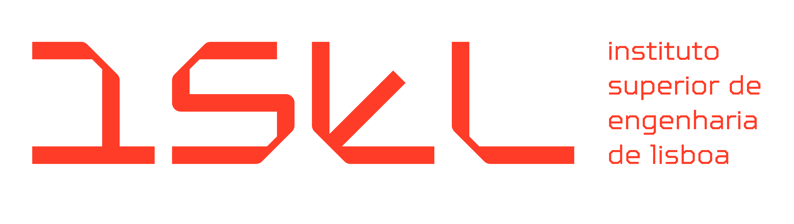
Resumo da Proposta de Ideia Para Trabalho Final de Mestrado - 2025/2026
—————————————————————————————————

Código: TFM1
Título da proposta de TFM: Protocol and infrastructure agnostic message exchange
Orientador(es): José Simão
E-mail de contacto: jose.simao@isel.pt

Natureza da proposta de TFM:
☐ Dissertação ☒Trabalho de Projeto ☐ Estágio de Natureza Profissional
Mestrado(s) onde a proposta é oferecida:
☐ MEET ☒ MEIC ☐ MEIM
Resumo da proposta de TFM:
There are many available message queue providers and similar services such as AWS SQS, Azure Queues and Google Pub/SUB. When a provider is chosen for an application it can be tricky to switch to a different one without breaking functionality. Meaning that it might be beneficial to abstract implementation details and provide useful features such as automatic resource allocation. Messages can also be exchanged in diverse contexts such as in process, within the same machine, through the network and with queues. This project proposes the development of a library that is capable of exchanging messages in those contexts, abstract all networking and queue details and make automatic resource allocation.
Palavras chave: Queues; Message oriented middle-ware; Protocols

